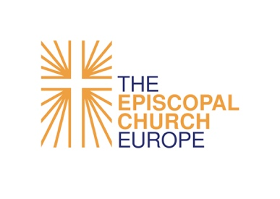
The Convocation of Episcopal Churches in Europe

Grant Project Learning Report

Name of Grant Recipient
or Congregation:
Name of Grant Officer
or Digital Ministry Leader:
Phone number/address/email:
Grant Category:
(General / Exceptional / German / Rowthorn / Digital Ministry)
Grant Title:
Purpose (in a few words):
Amount requested, in €:
Amount spent, in €:
Goals of the Convocation’s 2017 Strategic Plan that the Grant supported:
 | ❒ I. Becoming Vibrant Congregations |  | ❒ II. Developing New Communities
 | ❒ III. Fostering Ecumenical and Interfaith  Projects  ❒ V. Engaging European Policy-makers in  the Promotion of Justice, Peace, and  the Integrity of Creation  Other goals that the Grant supported:  ❒ Digital Ministry Enrichment |  | ❒ IV. Being a Progressive and Prophetic Christian  Witness in Secular Societies

- How did you evaluate the success of this project?
- What is the most lasting impact of this project to date?
- Would you recommend that other congregations undertake a similar project through a similar process? Why or why not?
- What surprised you about the implementation or impact of your project?
- What failures or setbacks did you encounter in your project? What did you learn from them?
- Where have you shared the knowledge gained or the community impact of this project? Do you need help to get started sharing these results?
Some examples: individual conversations with community members, congregational worship services or meetings, social media posts, email newsletter, or church website, Convocation newsletter, local news media.
- Who among your congregation are willing to explain your project or its implementation further? Are there leaders willing to be interviewed for details about how this went?
- Have you submitted your Report of Expenditures for Grants Received?

