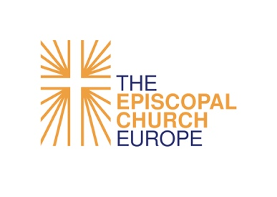
The Convocation of Episcopal Churches in Europe

Grant request form for grants to be disbursed in 2022
To apply for a grant from Convocation Budget of the year indicated above, please complete this form and submit it with the required financial reports, as well as the Report of Expenditures for Grants Received and Grant Project Learning Report for the year just ended (if you received any grant),
no later than May 31 of the year before the grant period, to:
Finance Committee
Convocation of Episcopal Churches in Europe
23 Ave George V
75008 Paris, France
E-mail: office@tec-europe.org

Applications for the FY22 Grant Cycle are due on May 7, 2022. They should be submitted to Sophie Plé at accounts@tec-europe.org.

Name of Grant Recipient:

Name of Grant Officer:
Phone number/address/email:
Grant Category: (General / Exceptional / German / Rowthorn)
N.B.: Digital Ministry Enrichment Grants are applied for using a form at this link)
Grant Title:
Purpose (in a few words):
Amount requested, in €:
Goals of the Convocation’s 2017 Strategic Plan that the Grant will support:
 | ❒ I. Becoming Vibrant Congregations |  | ❒ II. Developing New Communities
 | ❒ III. Fostering Ecumenical and Interfaith  Projects  ❒ V. Engaging European Policy-makers in  the Promotion of Justice, Peace, and  the Integrity of Creation |  | ❒ IV. Being a Progressive and Prophetic Christian  Witness in Secular Societies

The following questions are designed to help us all prayerfully and respectfully reflect on the purpose of the grant and how the experience and knowledge gained will benefit not only the recipient but the wider Convocation.
- Please give a description of the project or of the intended use of the funds.
- Please explain in what ways this proposal supports one or more of the goals of the Convocation’s 2017 Strategic Plan.
- How will the project you propose provide an example of a way for other congregations to grow spiritually, educationally, or in Christian service?
- What the difference this project will make in the life of your community?
- What is your theory of change? In other words, how do you believe the difference you want to make will be made?
- How will you evaluate the results of your project?
- Please explain how you plan to share the knowledge learned with another parish or with the wider Convocation as a whole.
- Please give a breakdown of the projected budget.
- Does this grant represent the total cost of the project? If not, what is the total cost?
- How much of this project budget will be covered from your own budget?
- To what other funding sources have you applied for support? What has been granted and from what organization?
- How will you prepare this year to continue the project in the next year without the Convocation’s financial support (if applicable)?
- Have you submitted your Parochial Report for the previous year, and attached your year-to-date statement for the current year to this request? If you received a grant the previous year, have you submitted your Grant Expenditure Report and Grant Project Learning Report?

